Abstract Reasoning

What are abstract reasoning tests and why are they used?

**Abstract reasoning tests** (also known as [inductive reasoning](https://www.wikijob.co.uk/content/aptitude-tests/test-types/inductive-reasoning-test) or [diagrammatic reasoning](https://www.wikijob.co.uk/content/aptitude-tests/test-types/diagrammatic-reasoning) tests) are widely used within selection processes to assess a candidate's general intellect and ability to work out new concepts and abstract ideas, rather than testing their prior knowledge. They are closely correlated with IQ tests, and rely upon the candidate's ability to see the underlying logic in a pattern of symbols or shapes (instead of relying on words or numbers).

This type of test is useful to employers because the ability to answer [abstract reasoning](https://linklyhq.com/l/A) questions is independent of educational experience and cultural background, and can be used to provide an objective indication of intellectual potential.They are particularly useful for jobs where problem-solving and initiative are important, or where candidates will need to deal with complex data, or perform non-routine tasks where initiative is required.

That said, [abstract reasoning](https://linklyhq.com/l/A) questions may be used by any employer as an assessment for any position, as they are seen to be a good measure of general intelligence, and test your ability to perceive spatial relationships and work out co-relationships, without any prior knowledge of language or mathematics.

To successfully complete [abstract reasoning](https://linklyhq.com/l/A) tests, you need to be able to think creatively and use lateral thinking (also known as fluid intelligence) to solve novel problems. You also need to see the relationships between shapes and figures, identify rules and similarities, and quickly apply these to identify the answer.

If you want to take practice [abstract reasoning](https://linklyhq.com/l/A) tests and improve your performance, [**click here**](http://www.jobtestprep.net/affiliates/traffic.php?id=23&tid1=wikijob&tid2=abstract-reasoning-copy&url=https://bit.ly/14u8qG2).

Report this ad



Success in [abstract reasoning](https://linklyhq.com/l/A) tests is all about spotting the patterns.

What to expect from your abstract reasoning test

[Abstract reasoning](https://linklyhq.com/l/A) tests are designed to be challenging, in order to differentiate between candidates and to identify the maximum performance they are capable of. They usually have tight time scales, and questions that rapidly increase in difficulty. This means that you will need to identify more rules to solve the problems, and that the complexity of these rules is likely to increase.

While there are many permutations of question types and formats, there are some general concepts which are common, and it can be useful to familiarise yourself with these.

Common question types in abstract reasoning tests

Question 1: Identify the missing square

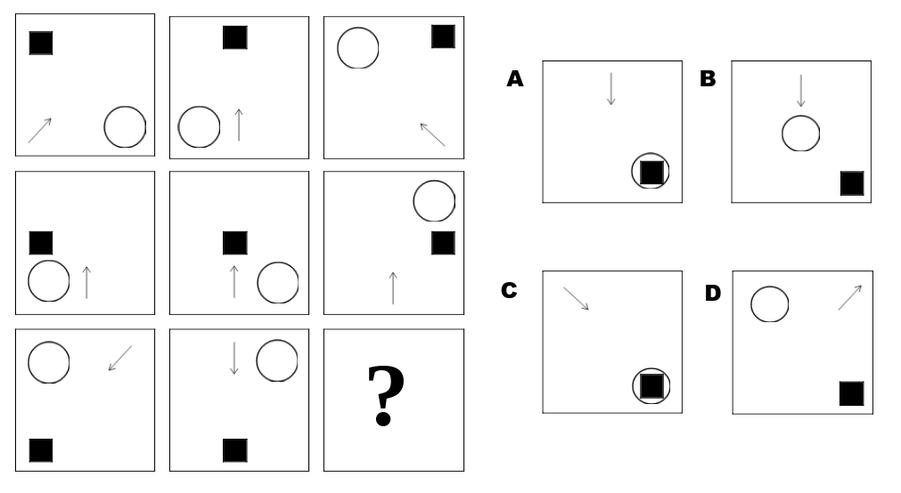

This type of question requires you to look at the patterns in the squares and understand their relationship to one another, so as to identify the missing square.

There are three rules to spot in this question. Firstly, there is a *relative positional rule*: the position of the black square corresponds to the position its square holds within the diagram. Secondly, there is a *movement rule*, in that the circle moves around the boxes in a clockwise position. Finally, the arrows in the first and third columns are reflections of one another. The correct answer is therefore **C**.

Question 2: Complete the sequence

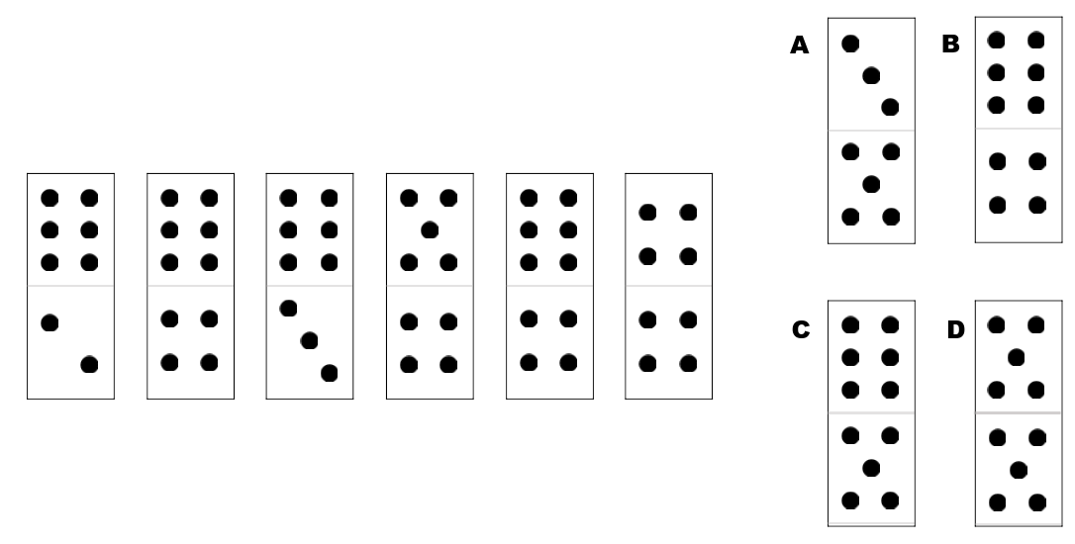

This requires you to identify and understand the pattern behind the order in which the dominoes are presented. There are two patterns here. The first, third and fifth (and therefore seventh) dominoes have the rule that the number of the top is six and the number on the bottom is increasing by one each time. The second pattern includes the second, fourth and sixth dominoes, and has the rule that the number on the bottom is four and the number at the top is decreasing by one each time. The correct answer is therefore **C**.

Question 3: Identify the odd one out

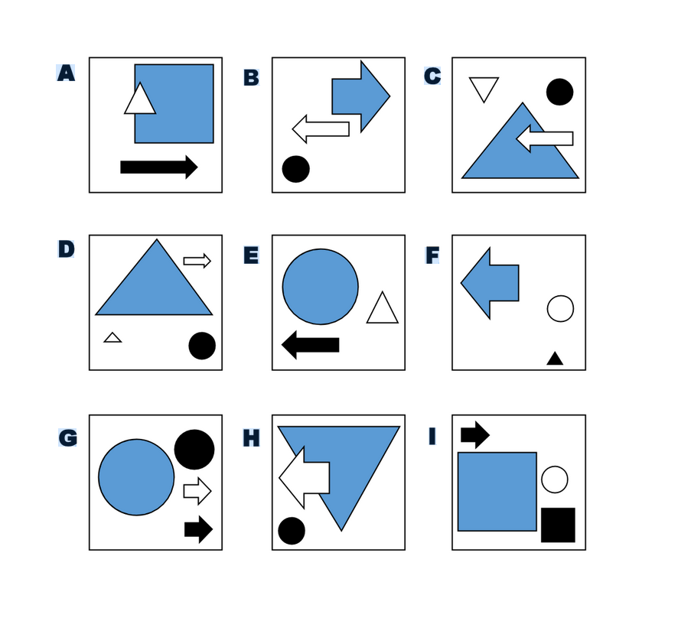

This type of question requires you to look at some data, identify the pattern or rules, and then spot which square does not meet those rules. Watch out for relative position, number of items, relationship between items, colour, shape, and orientation of shapes: there are many different variations on these rules and there may be some extraneous data in there that complicates the rules.

For example, in this question some of the squares have three items in and some have four – you need to work out whether or not that is important. In this particular case, there are two rules. The first is that the largest shape must be grey, and the second is that the bottom shape must be black. The odd one out is therefore **C**, as the bottom shape is stripey and not black.

Question 4: 1 is to 2, as 3 is to 4

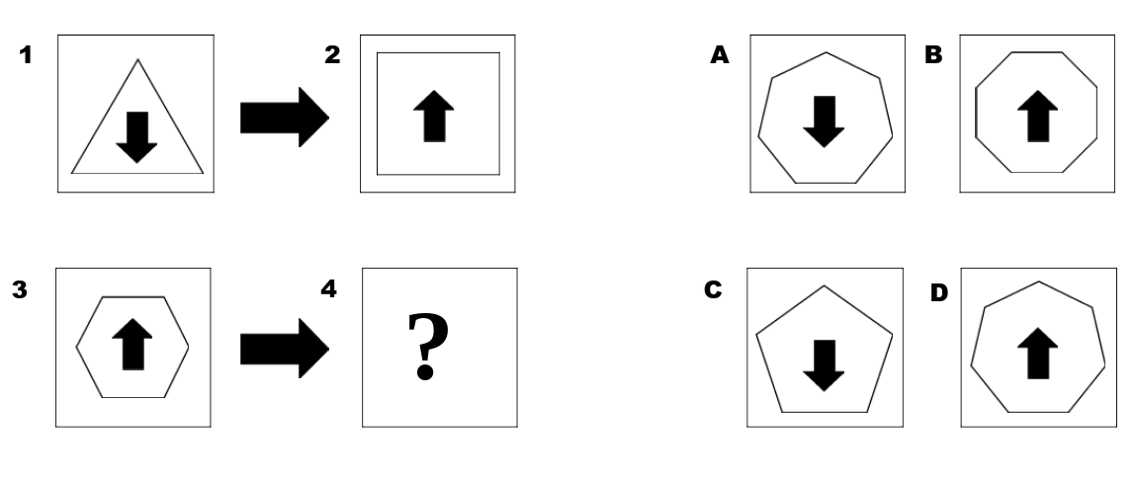

This type of question is all about **relationships between data**: being able to recognise what links two boxes together and then apply this rule to a new shape to solve the problem.

There are two rules here. First, the shape in box 2 has one more side that the shape in box 1. As the shape in box 3 has six sides, the correct shape for box 4 must have seven sides. The second rule is around the arrow and the rule is that for shapes with an even number of sides, the arrow points up. For shapes with an odd number of sides the arrow points down. The correct answer is therefore **A**.

Tips on how to prepare for your abstract reasoning test

[Abstract reasoning](https://linklyhq.com/l/A) ability is closely correlated with general intelligence. However, familiarity with the types of questions you are likely to encounter and some strategies for solving the questions will certainly help you perform at your best. Here are our five top tips:

1. Many people find that they enjoy the mental challenge of solving [abstract reasoning](https://linklyhq.com/l/A) tests! There is a range of **puzzle books and apps** available that you can use to practise with. Similarly, many test publishers provide [practice tests](https://linklyhq.com/l/E) that you can access, such as Graduate Monkey and JobTestPrep; this is certainly worth doing.
2. It can be useful to develop a **mental checklist** of strategies to solve [abstract reasoning](https://linklyhq.com/l/A) questions, such as a list of different rules that govern data like size, shape, number etc. This gives you a starting point to think about questions and can help you work methodically in the test.
3. Look at **one rule at a time**. There may be extraneous data within the question, which is designed to confuse you. Looking at only one aspect of the question at a time can help you work out what is important and what isn’t.
4. **Manage your time**. Sometimes you will come up against a question where you just cannot see the answer. On these occasions, don’t spend too much time on it, move on and if you have time at the end, go back and check it.
5. If you’re struggling to find a pattern, **sometimes there are clues in the answers**. Look for any patterns or themes in the possible answers; that might help you spot what is important within the question. For example, if you have a sequence of shapes and all of the answers are squares or triangles, you know that the next shape in the sequence must be either a square or a triangle and that can help you work out why.

Report this ad

Further information on aptitude tests

You may also want to check out these articles:

* [**Numerical reasoning tests**](https://www.wikijob.co.uk/wiki/numerical-reasoning). These tests require you to answer questions based on statistics, figures and charts.
* [**Verbal reasoning tests**](https://www.wikijob.co.uk/wiki/verbal-reasoning). A means of assessing your verbal logic and capacity to quickly digest information from passages of text.
* [**Intray exercises**](https://www.wikijob.co.uk/wiki/how-succeed-tray-and-e-tray-exercises). A business-related scenario that assesses how well you can prioritise tasks.
* [**Diagrammatic tests**](https://www.wikijob.co.uk/wiki/diagrammatic-reasoning). Tests that measure your [logical reasoning](http://www.jobtestprep.net/affiliates/traffic.php?id=23&tid1=wikijob&tid2=aptitude-tests-copy&url=https://bit.ly/1VIEahZ), usually under strict time conditions.
* [**Situational judgement tests**](https://www.wikijob.co.uk/wiki/situational-judgement-test). Psychological tests that assess your judgement in resolving work-based problems.
* [**Inductive reasoning tests**](https://www.wikijob.co.uk/wiki/inductive-reasoning-test). Tests that identify how well a candidate can see the underlying logic in patterns, rather than words or numbers.
* [**Non-Verbal Reasoning Tests**](https://www.wikijob.co.uk/content/aptitude-tests/test-types/non-verbal-reasoning). A way to tests candidates' 'raw' [cognitive ability](https://linklyhq.com/l/J) outside of their language skills.
* [**Cognitive ability tests**](https://www.wikijob.co.uk/wiki/cognitive-ability-test). A measurement of general intelligence, covering many categories of aptitude test.
* [**Mechanical reasoning tests**](https://www.wikijob.co.uk/wiki/mechanical-comprehension-test). These assess your ability to apply mechanical or engineering principles to problems; they are often used for technical roles.
* [**Watson Glaser tests**](https://www.wikijob.co.uk/wiki/watson-glaser). Designed to assess a candidate's ability to critically consider arguments; often used by law firms.
* [**Spatial awareness tests**](https://www.wikijob.co.uk/content/aptitude-tests/test-types/spatial-awareness-test). These tests assess your capacity to mentally manipulate images, and are often used in applications for jobs in design, engineering and architecture.
* [**Error checking tests**](https://www.wikijob.co.uk/content/aptitude-tests/test-types/error-checking-test). An unusual type of aptitude test that focuses on your ability to identify errors in complex data sets.
* [**Predictive Index tests**](https://www.wikijob.co.uk/content/aptitude-tests/test-types/predictive-index-tests). A cognitive and personality assessment used by (mainly US) recruiters.

Related Content

[Aptitude Tests](https://www.wikijob.co.uk/content/aptitude-tests/test-types/aptitude-tests)[Diagrammatic Reasoning](https://www.wikijob.co.uk/content/aptitude-tests/test-types/diagrammatic-reasoning)[EEI Tests](https://www.wikijob.co.uk/content/aptitude-tests/test-types/eei-test)[Mechanical Comprehension Test](https://www.wikijob.co.uk/content/aptitude-tests/test-types/mechanical-comprehension-test)[Myers-Briggs](https://www.wikijob.co.uk/content/aptitude-tests/test-types/myers-briggs)[Numerical Reasoning Tests](https://www.wikijob.co.uk/content/aptitude-tests/test-types/numerical-reasoning-tests)[Situational Judgement Test](https://www.wikijob.co.uk/content/aptitude-tests/test-types/situational-judgement-test)[Spatial Awareness Test](https://www.wikijob.co.uk/content/aptitude-tests/test-types/spatial-awareness-test)[The Neo Personality Inventory Test](https://www.wikijob.co.uk/content/aptitude-tests/test-types/neo-personality-inventory-test)[The SHL OPQ Assessment](https://www.wikijob.co.uk/content/aptitude-tests/test-types/shl-opq-test)[Types of Aptitude Test](https://www.wikijob.co.uk/content/aptitude-tests/test-types/types-aptitude-test)[Verbal Reasoning Test](https://www.wikijob.co.uk/content/aptitude-tests/test-types/verbal-reasoning-test)[Watson Glaser](https://www.wikijob.co.uk/content/aptitude-tests/test-types/watson-glaser)[What is a Psychometric Test?](https://www.wikijob.co.uk/content/aptitude-tests/test-types/what-psychometric-test)